A short history of Afghanistan

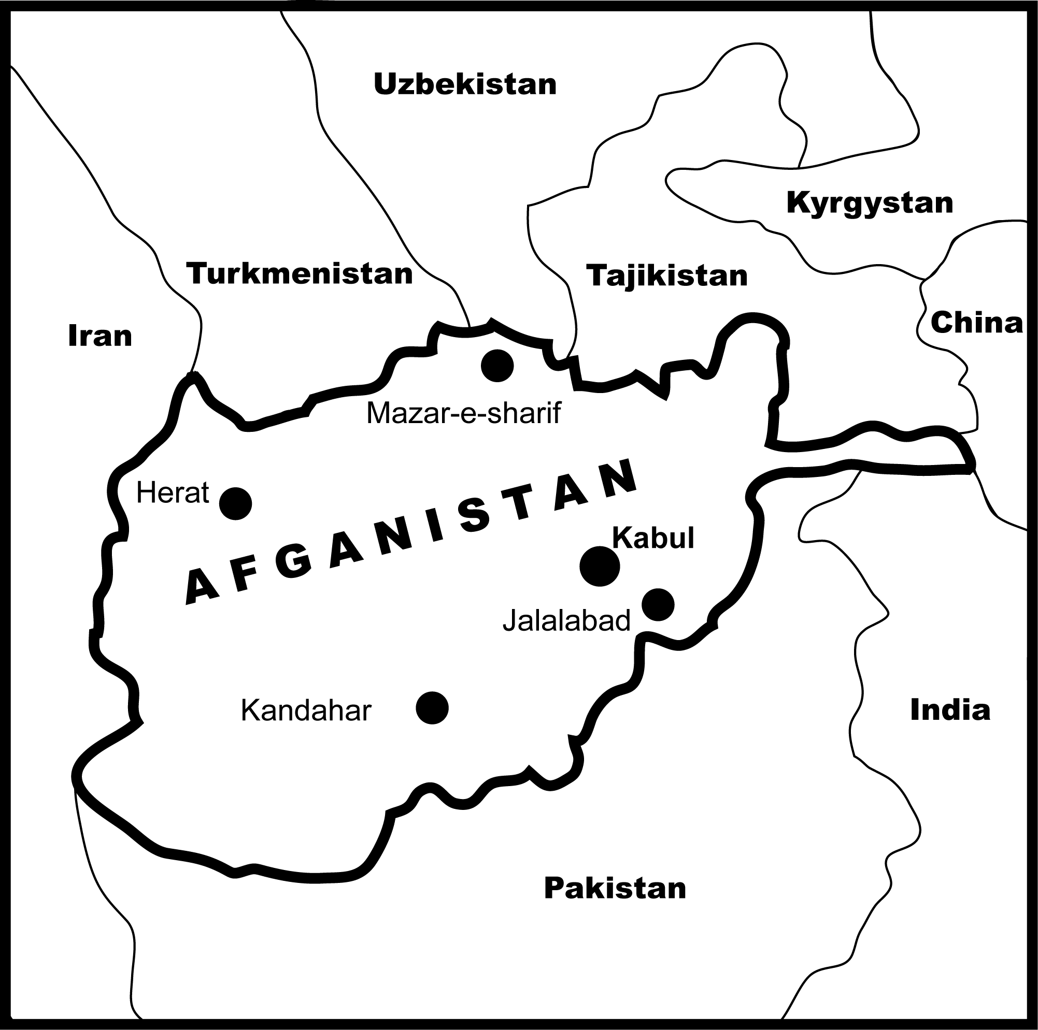

Writer:
Dr. Ghulam Ahmad Waak

Contents

Introduction

- Short look at the Geographical location and ancient history of Afghanistan
A. Geographical location
B. Ancient history of Afghanistan
- Bibliography
Introduction

Afghanistan is a mountainous country, located as the cross-roads of Asia. Afghanistan has a long history, which includes several name and boundary changes. Ariana, Khorasan and ultimately Afghanistan are the names which were each cradles of civilization at a time and some times asylums for the local fighters. In the history of Afghanistan we see the bright and civilized periods but several times of fighting, ruining and desolation. Especially in the last three centuries was in fighting against neighboring countries and in civil wars. The physical shape of Afghanistan is in a way that through out the history different clans and tribes of the world based on warring problems have seek asylum here and easily have been combined and mixed up with native tribes in certain and safe hiding places. Based on this matter this country is called the intersection of Asia, with multinational people having different languages and also the centre for the coincidence of different cultures and religions. Therefore the liberate nature of independent life has mostly the tribal characteristics and mountainous living of the people has changed it to a spiritual power. This power of the people of Afghanistan was used only in the fighting ways and not for economical development and progress.

Studying about the above lines and subjects requires absolutely huge investigations that what idea does it create for the next young generation of Afghanistan. As a matter of fact, of course the next generation of Afghanistan has to define and distinguish the positive aspects of their ancestor combats from the negative ones. Actually all the purpose for independence, combat, sacrifices and warring covers the meaning that people would be able to work liberty for development. Afghan people also need a peaceful country and development. Now Afghanistan has the possibility to re-make their country. In this way the international community will help with keeping their interests in the region. Peace in Afghanistan and a civilized Afghanistan is very necessary for the peace in South Asia, Central Asia, Middle East and for all the world. Many countries of the world having managed to live together by reciprocal help, have built countries to highest degrees of civilization and development and their people live prosperous and civilized.

Geographical location and ancient history of Afghanistan

- Geographical location of Afghanistan:

Afghanistan is a mountainous country in Asia. Area of Afghanistan is 647500 sq km. The famous mountains are Pamir, Hindukush, Kohe baba, Sulaiman and Spinghar. Highest mountains are in the north-east and south-east, rugged mountains are in the north and south-west. The famous rivers are Amudarya in the north, Helmand in the south-west, Harirud in the west, Kabul river in the central area and Kunar in the east. The climate of Afghanistan is arid and semiarid (cold winter and hot summer).
Natural resources are natural gas, petroleum, coal, copper, chromate, talk, barites, sulfur, lead, zero, salt, precious and semiprecious stones.

New information says that in Afghanistan live about 29928987 people (July 2005). In Afghanistan live about 40 ethnic groups, Pashtons, Tajiks, Hazara Uzbek, minor ethnic groups (Pashai, Baloch, Turk and others). 99% people are Muslims (sunni Muslems and shi’a Muslems) and 1% are Hindus and Sik’hs. Therefore in Afghanistan are about 30 different languages, Pashto, Dari, Turkic languages (Uzbek and Turkmen), minor languages (Pashai, Balochi and others).

Administrative divisions are 34 provinces. The capital of Afghanistan is the Kabul city and other famous cities are Kandahar, Herat, Mazar-e-sharif and Jalalabad.
Afghanistan is an extremely poor, landlocked country, highly dependent on foreign aid, farming and livestock raising (sheep and goats), and trade with neighboring countries. Economic considerations have played second fiddle political and military upheavals during more than two decades of war, include the nearly 10-years Soviet military occupation (with ended 15 February 1992). During that conflict, one-third of the population fled the country, with Pakistan and Iran sheltering a combined peak of 4 to 6 million refugees. Gross domestic product has fallen substantially over the past 20 years. The majority of the population continues suffer from insufficient food, clothing, housing and medical care.

Industries are small-scale production of textiles, soap, furniture, shoes, cement, hand woven carpets, natural gas, coal and copper. Exports are fruits and nuts, hand woven carpets, wool, cotton. Imports are capital goods, food, textiles and petroleum.

B. Ancient history of Afghanistan:

Afghanistan has a long history of about 6000 years. In the beginning its name was Ariana (3300 B.C. until 9th century A.D.). The famous governments in this period are Ariana Empire, Achaemenia Empire, Graeco-Bactria, Kushanids and Ephthalites.
After the expansion of the Islamic religion in 9th century its name became Khorasan. The famous governments in this period are Taherids government, Safavids government, Ghaznavids Empire, Timorids Empire, Mangols Empire, Safavids Empire, Shaibanids and Hotakioes.

In 1747, Ahmad Shah Dorani politically united the country, which later was named Afghanistan. The name of Afghanistan belongs to all those people, who are living in Afghanistan. In this period were many difficulties, like civil wars, fighting against Great Britain Empire and fighting with neighboring countries.

Most important source on the ancient history of Afghanistan in the period of Ariana Empire is “Avesta”, a remarkable sample of ancient history of Afghanistan from which we have learned the names of a number of historical-cultural areas in the territory of Afghanistan dating to the 1st , Millennium B.C.

The Graeco-Macedonian army dealt a finishing blow at the decrepit Achaemenian Empire 330- B.C., after begun Graeco-Bactria civilization. In the 1stcentury of A. D. Buddhism became widespread in the period of Kushans Empire. The Arab expedition to Afghanistan began in the middle of the 7th century. In many regions the local rulers and the population offered fierce resistance and the caliphs and their vicegerents often had to dispatch troops once again to subdue the recalcitrant. At the turn of the 9th century there was a growth in the private land holdings and conventional holdings.
Islam expanded in south and central Asia through Afghanistan after the 9th century. The name of Afghanistan was Khorasan in that time. Khorasan was one part of the Islamic Empire. Khorasan was the first Islamic country, which was independent from Islamic Empire by Taher Fushanji (821-873).

In this period we see the civilize governments in Afghanistan and we see the development of the science and culture in Afghanistan and in the neighboring Islamic countries. Bukhara and Samarqand were very famous Islamic religious and scientific centers in Central Asia. In the18th century was emergence of the new small Islamic governments in the region. In this period began the civilization of Europe. Industrial revolution in Europe was a huge development for the west countries. After that Great Britain Empire ruled on Afghanistan and on the other Islamic countries in Asia. Afghanistan independence from Great Britain Empire was in 1919.

Bibliography

- Abdul Ghani. A review of political situation in central Asia. London, 1924
- Adamec L. Afghanistan foreign affairs to the mid 20th century. Tucson, 1974
- Ali Mohammad. Afghanistan. An historical sketch. Part 2. No-1, Kabul, 1957
- Babaev A. and others. Bastanshinasi-e-Afghanistan. “Archaeology of Afghanistan”. Kabul, 1984 “In Dari language”
- Bosworth C.E. Iran and Islam. Edinburg, 1971
- Davidov A.D. Afghanistan. Moscow, 1993 “In Russian language”
- Diago Kordoviz and Slig Hris. Soviet Union increase to Afghanistan. Translate by A. Jabbar Sabet. Peshawar, 1996
- Dupree Louis. Afghanistan. New York, 1970
- Dupree Louis. Afghanistan in the 1970s. New York, 1974
- Dupree Louis. A note on Afghanistan. AUFS reports. S. Asia series. No- 15 and 2, 1971
- Dupree Louis. Islam in politics. “Muslim world” No-16, 1966
- Dupree Louis. The democratic republic of Afghanistan. AUFS reports. Asia. No-32, 1979
- Fazal R. Jami-ol- tawarikh. “complex of history” Tome 1-2. Teheran, 1959”In Persian language”, 1338
- Fraser. Afghanistan. Oxford, 1950
- Gankovski Yu.V. and others. A history of Afghanistan. Moscow, 1985
- Ghafoorov B.G. and others. History of tajiks. Tom 1. Moscow, 1963 “In Russian language”
- Ghobar G.M. Afghanistan dar masir-e- tarikh. ”Afghanistan in the duration of history” Kabul, 1967 “In Dari language”
- Gregorian Varton. The emergence of modern Afghanistan (1880-1946). Stanford, 1969
- Griffiths John. Afghanistan. London, 1967
- Habibi A. Da Afghanistan pikhlik. “A chronology of Afghanistan. Kabul”, 1947 “In Pashto language”
- Habibi A. Jonbesh-e-mashrotiat dar Afghanistan. “Constitutional movement in Afghanistan”. Kabul, 1984 “in Darei language”
- Haroon Khpal. Aafarida hai mahjoor Alama Abdulhai Habibi. ”The biography and publication of Abdulhai Habibi”. Kabul, 1988 “In Dari language”
- Hashimbikov H. Uzbeks of the north Afghanistan. Moscow, 1998 “In Russian language”
- Iqbal Ali Shah. The tragedy of Afghanistan. London, 1933
- Ivanov N.A. Islam. Moscow, 1986
- Journal of Afghanistan’s studies. Ariana. 2001-2002. Stockholm, Sweden
- Journal of Cultural, Social and Political studies of Afghanistan. Sabawoon. Peshawar, 2000
- Kohzad A.A. In the highlights of modern Afghanistan. “Afghanistan” No-2. Kabul, 1957
- Kushans and the silks road. An international seminar on Afghanistan. Kabul, 1990
- Lyakhovski A. Tragedy of Afghanistan. Moscow, 1995 “In Russian language”
- Mohammad A. Progressive Afghanistan. Lahore, 1933
- Newell R. The politics of Afghanistan. Ithaca, 1972
- Nikki R. K. Said Jamalo-od-din Afghani. University of california, 1972
- Olmstead. History of the Persian impire. Chicago, 1948
- Paakkulainen Erkki and Leena Saraste. On the road-sides of Afghanistan. Vanta, 1987 ”In Finnish language”
- Paakkulainen Erkki. Afghanistan (Difficult problems). Painoseppa oy, 1992 ”In Finnish language”
- Petroshivski I.P. Islam in Iran in 7-15th centuries. University of Leningrad, 1966
- Poullada L. Reforms and rebellion in Afghanistan (1919-1929). New York, 1973
- Russian and Afghan writers. The question of the war and peace in Afghanistan. Peshawar, 1999 “In Persian language, translate by Aziz Arianfar from Russian language”
- Samuel P.H. The clash of civilizations and the remaking of world order. London,1998
- Sykes P. A history of Afghanistan. London, 1940
- Timerkhanov L. Hazara. “One of the nationalities in Afghanistan”. Moscow, 1972 “In Russian language”
- Waak G.A. Constitutional movement in the period of Emir Habibullh. M.A., Discertation. Kabul, 1985 “In Dari language”
- Waak G.A. Constitutional movement in Afghanistan. Ph.D, Discertation. Moscow, 1994 “In Russian language”
- Wriz Sh.Z. Some pages of the history of Afghanistan. Peshawar,1999 “In Dari language”
- CIA-The world fact book-Afghanistan. “Internet”
- Radio BBC. Pashto, Dari and Persian programs
- Radio voice of America. Pashto and Dari programs
- Radio Liberty. Pashto and Dari programs
- Radio DW. Pashto and Dari programs

